**LAB:**

**Z/OSMF – CHOOSE YOUR OWN TOPIC**

**Getting started with   
z/OS Data Gatherer REST Services**

Alexander Giemsa

IBM Corporation

[alexander.giemsa@ibm.com](mailto:alexander.giemsa@ibm.com)

Note: See the section later in this template about using bulleted and numbered lists.

List any hardware, software or other materials that are required to perform the exercise.

[instr_ex]

Provide details about this exercise for instructors, including required information the instructor must tell the students, common student problems, hints and tips, location of solutions.

[Unconditional]

Content:

Introduction 3

Lesson 1 – Getting started with the Swagger interface 5

Lesson 2 – Authenticate to REST API and use simple REST requests 9

Lesson 3 – Use REST requests with filter 21

Next steps 28

Use IBM® z/OS® Data Gatherer SMF REST APIs 28

Learn more about z/OSMF Data Gatherer REST services 28

Figures:

Figure 1 Overview of z/OS Data Gatherer SMF REST services 3

Figure 2 Swagger UI link to OpenAPI document 5

Figure 3 Generated server url 6

Figure 4 SMF REST API documentation in schema section 7

Figure 5 SMF REST API documentation 8

# Introduction

The SMF REST services of the z/OS Data Gatherer provide access to SMF data through REST calls. As shown in the following picture, SMF REST services run inside a z/OSMF managed Liberty server instance. It provides several REST request paths (endpoints) which are to be called by client applications. The IBM® z/OS® Data Gatherer GRBSMFR service is called to retrieve SMF record data and/or metadata on the SMF dataset, depending on the request input. The application then processes the data into a JSON representation of the requested SMF data.

Figure 1 Overview of z/OS Data Gatherer SMF REST services

Swagger is an open source software framework that allows developers to design, build, document, and use RESTful APIs (application programming interfaces). It provides a set of tools and specifications for creating interactive API documentation, making it simpler to understand and use APIs.

At its core, Swagger uses the standard specification format OpenAPI to define the structure and behavior of APIs. The RESTful API of the z/OS Data Gatherer includes an OpenAPI document as part of the application.

In the following exercises, you are introduced to the Swagger UI, which is a convenient way to interact with the z/OS Data Gatherer REST API server. You learn how to:

* Use the Swagger interface.
* Authenticate and make REST requests.
* Use filters within REST requests.

No previous knowledge about Swagger UI or REST services is needed.

Allow at least 30 minutes to complete the exercises in this scenario.

# Lesson 1 – Getting started with the Swagger interface

Use the Swagger interface and IBM® z/OS® Data Gatherer REST API documentation.

Swagger™ provides a simple interface that is called Swagger UI, which automatically generates interactive API documentation based on the Open API specification. This documentation includes details about each endpoint, such as the HTTP methods it supports, input parameters, expected responses, and even sample requests that can be run directly from the documentation.

You must start the browser to load Swagger interface.

1. To start working with Swagger UI, open your browser, preferably **Firefox** or **Chrome** with JSON

Enter the following URL in the address bar:

<https://share.centers.ihost.com:444/zosmf/zosdg/smf/swagger-ui/index.html#/> .

1. At the top of your browser screen, you notice general information about z/OS Data Gatherer REST Services and the link to the OpenAPI specification document: /zosmf/zosdg/smf/v3/api-docs. If you click the link with the right click and then open in the new tab, you can find the full technical description of the API.

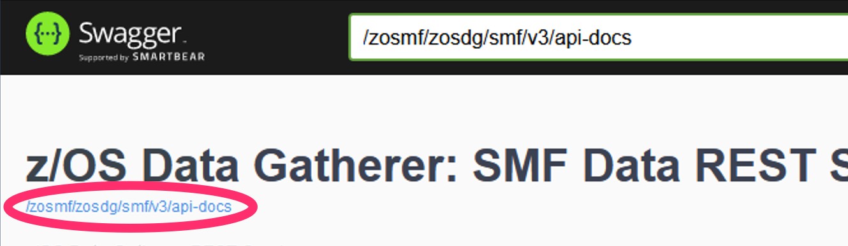

Figure 2 Swagger UI link to OpenAPI document

The Swagger UI interface presents the API documentation in a visually appealing and intuitive manner. Developer and API consumers are able to explore the API's capabilities, understand its inputs and outputs, and even test it without leaving the documentation.

1. Continue looking at Swagger UI.

Scrolling down, you can see the generated server url of REST services: https://share.centers.ihost.com:444//zosmf/zosdg/smf and the **Authorize** action button.



Figure 3 Generated server url

You will use **Authorize** in the next lesson to authenticate against z/OS Data Gatherer REST services.

1. Following the generated server URL you will find the list of Endpoints.

The Endpoints section is divided by the categories, such as:

* + Discovery.
  + SMF 113.
  + SMF 70.
  + SMF 71.

Each category has an arrow up or down to the right. When the arrow shows up, the category is expanded, and individual endpoints are shown. When the arrow shows down, the category is collapsed, and the endpoints are hidden. Clicking anywhere on the category line results in expanding or collapsing the category.

Discovery methods or endpoints are used to discover the content of the SMF data source, while all other methods are reading and retrieving SMF data.

When you expand the Discovery category, you can see 3 methods or endpoints inside:

* + GET /v1/smf/discover/dataset/exists/{datasetName}.
  + GET /v1/smf/discover/describe/{datasetName}.
  + POST /v1/smf/discover/describe/{datasetName}.

When you expand any of the endpoints, you see the information about that endpoint, the required or optional parameters and possible return codes.

Each of the following categories represents the supporting SMF record and contains one endpoint per SMF record subtype. For example section SMF 70 contains two endpoints:

* + GET /v1/smf/type/70/subtype/1.
  + GET /v1/smf/type/70/subtype/2.

1. If you scroll down, after Endpoints section, you can see the documentation in place inside Schema section:

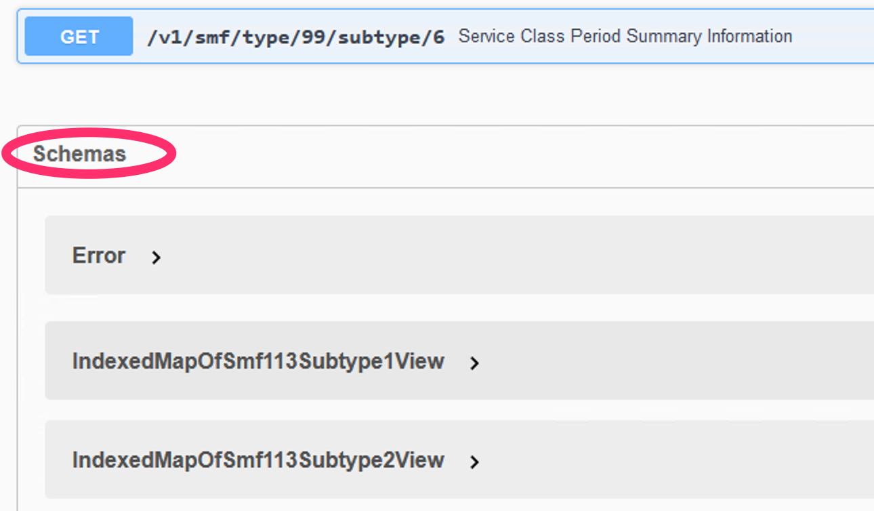

Figure 4 SMF REST API documentation in schema section

By clicking any item, for example SMF70_SUBTYPE1, you can expand it and investigate its structure.  
At the top, the expanded description lists all fields of a structure, e.g. the individual SMF70 fields. By clicking the “> […]” button next to a field information like its datatype and field description can be displayed. Likewise a “> {…}” button will expand a more complex structure.  
Below the fields you can find information on the substructures, e.g. the individual data sections for SMF70 Subtype 1.  
Any displayed substructure (e.g. SMF70_SUBTYPE1_PRODUCT_SECTION) is listed somewhere in the schema section but can be also directly investigated by clicking on it.  
The symbol “< * >” indicates a 1-n relationship and for example describes that a SMF70.1 record has multiple CPU Data Sections.

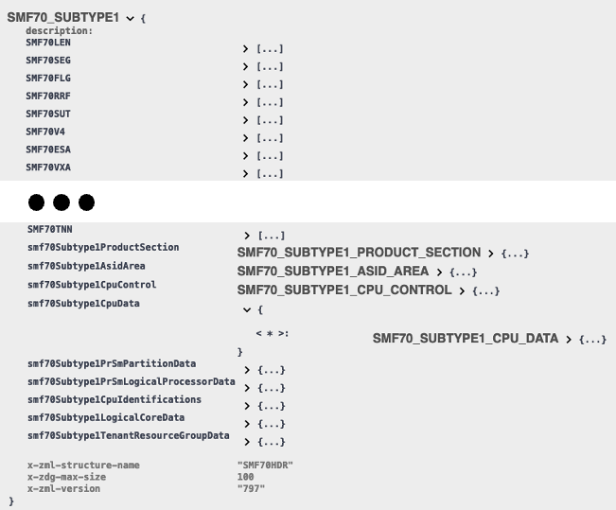

Figure 5 SMF REST API documentation

In summary, Swagger provides a comprehensive interface for documenting, and testing RESTful APIs. It simplifies the process of API development by promoting consistency, providing interactive documentation, and enabling seamless collaboration between API providers and consumers. In this first task, you got familiar with Swagger UI. The next step is to authenticate and make the first requests by using Swagger interface.

# Lesson 2 – Authenticate to REST API and use simple REST requests

In this exercise, you use IBM® z/OS® Data Gatherer REST services to check whether the data set with the provided name exists and to retrieve SMF data.

You use the web client program from the previous exercise.

Before you can make REST request, you need to be authorized. You can authorize by clicking **Authorize**, or you are requested to authorize when you submit the first REST request.

1. Click **Authorize** right to the Generated server URL:

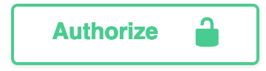

1. Log in with Username and Password provided by the instructor and click **Authorize** after it.

To close Available authorizations screen, click Close next to Logout.

1. Next, expand **Discovery** section to list the methods to discover the content of the SMF data source, if it is not already expanded:

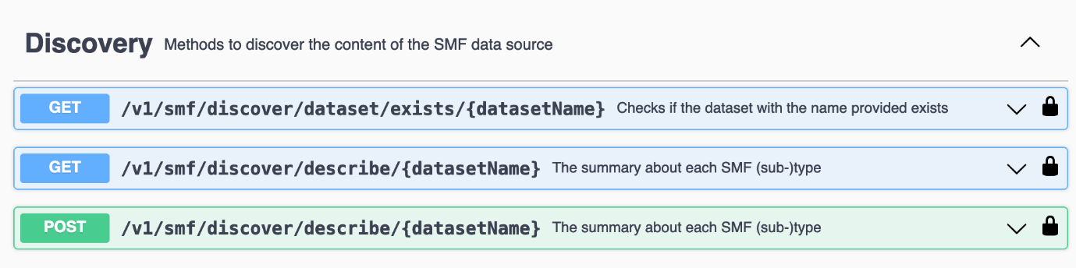

1. Now, expand the first method or the GET /v1/smf/discover/dataset/exists/{datasetName} endpoint, if not already expanded:

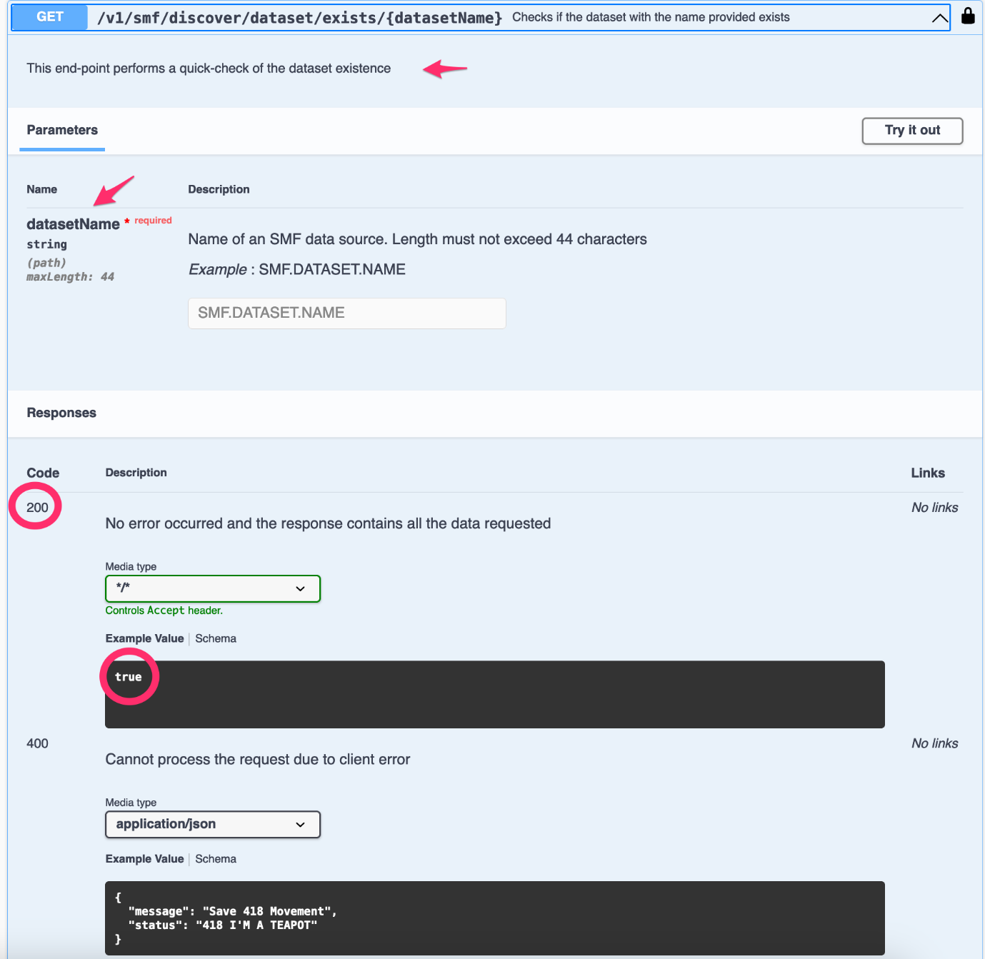

You can read that this end point checks the data set existence. The parameter **datasetName** is the only parameter and it is required. The result of the request is true, if the provided data set exists on the system. In that case, the expected return code is 200.

1. Click **Try it out**.

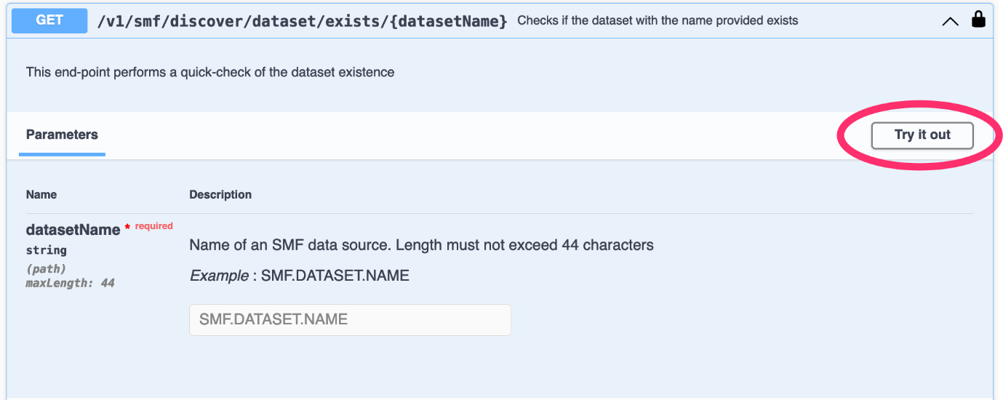

Provide **datasetName**: WRONG.DATASET and click Execute.

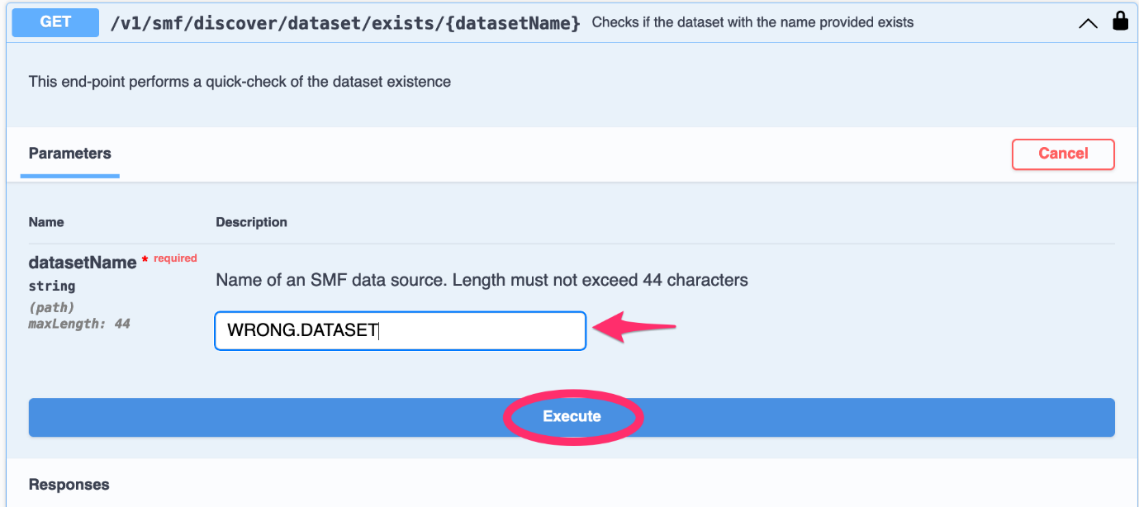

The result of the request is the JSON document with the message: Dataset 'WRONG.DATASET' not found and the Return code 404.

1. Now, provide datasetName: PMUENCH.SMFDATA.SMF7X.RECORDS and click **Execute**:

The result of the request is true with the Return code 200, which is good.

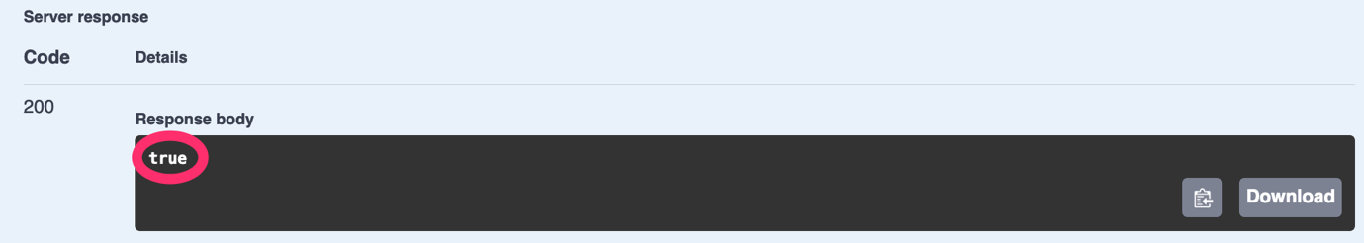

1. Next, look at the next endpoint from the Discovery section to extract metadata on the SMF dataset. Expand the method or the endpoint GET /v1/smf/describe/dataset/{datasetName}, and click **Try it out.**

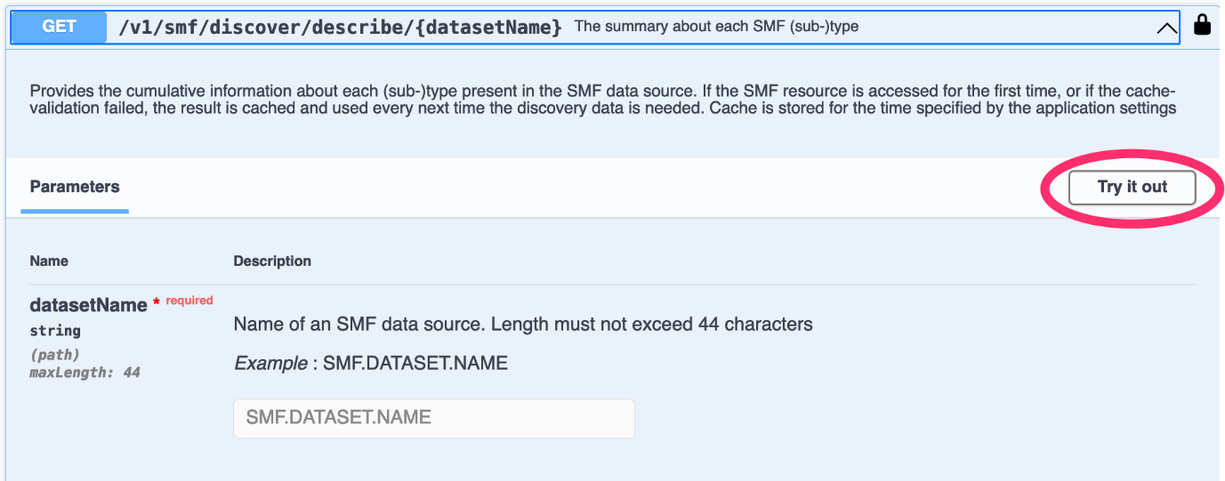

Provide datasetName: PMUENCH.SMFDATA.SMF7X.RECORDS and click **Execute**. The result of the request is the summary about each SMF subtype, with the Return code of “200”.

1. Copy the Request URL [https://share.centers.ihost.com:444/zosmf/zosdg/smf/v1/smf/discover/describe/PMUENCH.SMFDATA.SMF7X.RECORDS](https://share.centers.ihost.com:444/zosmf/zosdg/smf/v1/smf/discover/describe/PMUENCH.SMFDATA.SMF7X.RECORDS%20)  into the clipboard.   
  
  
  
Open the new tab in the browser, paste the Request URL in the address bar and press **ENTR**.

If Firefox is your browser of choice, or Chrome with JSON Viewer extension, you get a convenient format of the JSON document, with the possibility to expand and collapse the sections in the document.

1. Next, you try the endpoint from the next section to read and retrieve SMF data. Expand **SMF 70** section (if not already expanded) to list the methods to read SMF type 70 records:

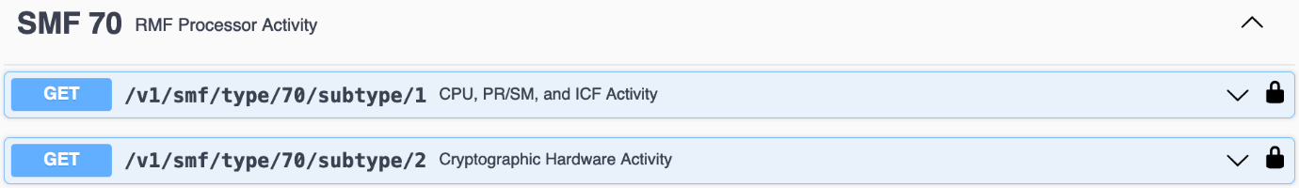

You can see the list of the endpoints for each subtype of SMF 70 record.

1. Next, expand the first method or the endpoint GET /v1/smf/type/70/subtype/1 and   
   click **Try it out:**

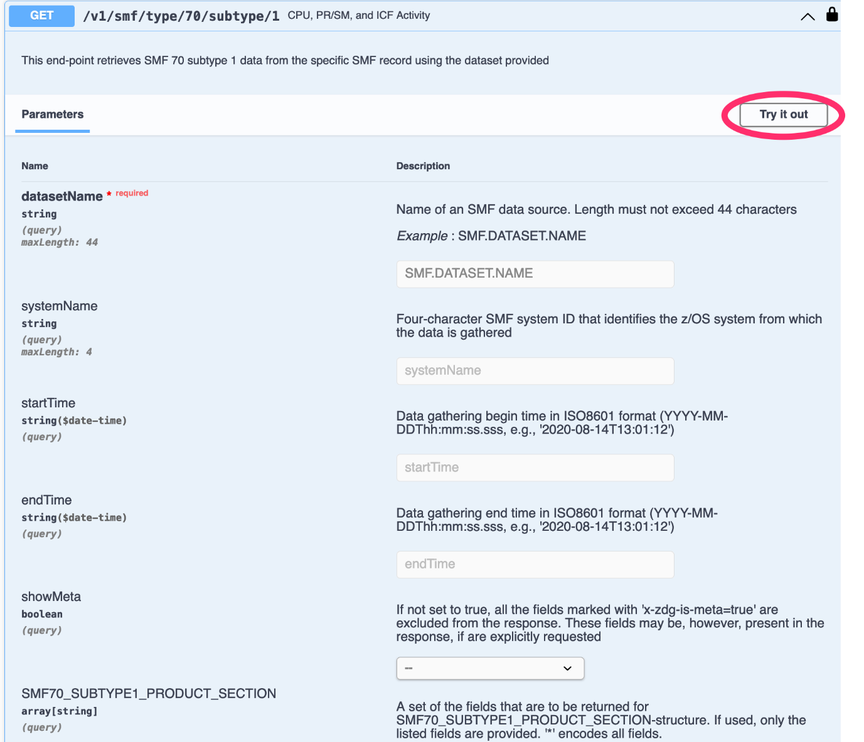

You can see the list of input parameters and filters. The only required input parameter is datasetName, while optional parameters are systemName, startTime and endTime.

If the parameter showMeta is set to true, other fields that are marked as "meta" are included into the response.

1. Put the name of the data set in the datasetName field: PMUENCH.SMFDATA.SMF7X.RECORDS and click **Execute**:

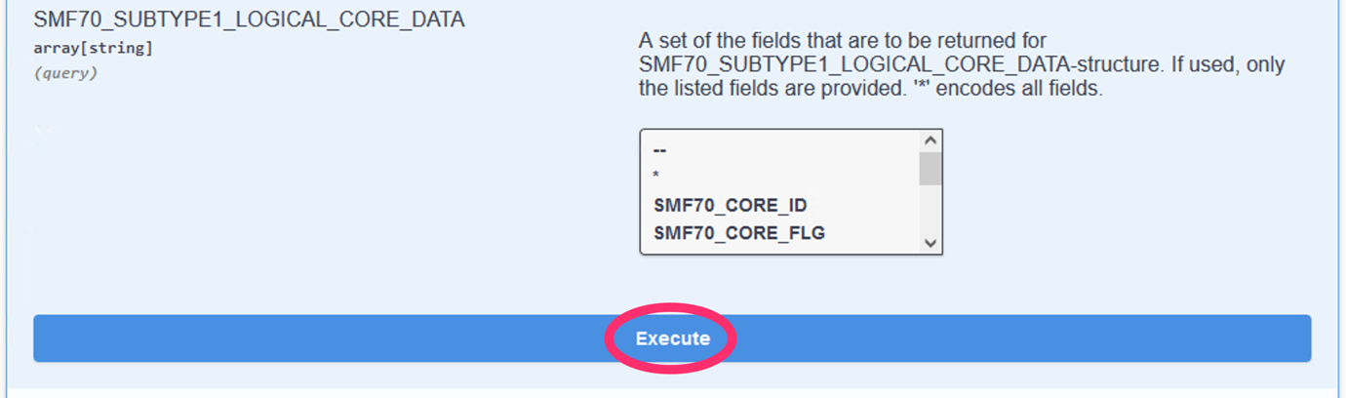

Now, the process could take longer the dataset records are read for the first time.

The result is the JSON document with the Return code of 200. The JSON document provides the array of the records of SMF type 70 subtype 1 from the provided data set.

Look at the result in the **Response body** after the **Execute**.

You can use the slider to scroll up and down:

The Request URL contains the URL of the current request.

1. Copy the **Request URL**: [https://share.centers.ihost.com:444/zosmf/zosdg/smf/v1/smf/type/70/subtype/1?datasetName= PMUENCH.SMFDATA.SMF7X.RECORDS](https://share.centers.ihost.com:444/zosmf/zosdg/smf/v1/smf/type/70/subtype/1?datasetName=PMUENCH.SMFDATA.SMF7X.RECORDS) into the clipboard (right click and copy with the mouse).

Open the new tab in the browser, paste the content of the clipboard in the address bar and press **ENTER**.

You get a convenient format of the JSON document, with the possibility to expand and collapse the sections in the document.

Review the content and close the tab when done

In this second task, you learned to authenticate and make first requests with minimal input parameters.

The next step is to make requests with more extensive use of other parameters to filter the data.

# Lesson 3 – Use REST requests with filter

In this exercise, you use IBM® z/OS® Data Gatherer REST services retrieve SMF data with more extensive use of other parameters to filter the data.

You use the web client program from the previous exercise.

1. If you closed the browser session from the previous exercise, open it again:

Enter the following URL in the address bar:

[https://share.centers.ihost.com:444/zosmf/zosdg/smf/swagger-ui/index.html#](https://share.centers.ihost.com:444/zosmf/zosdg/smf/swagger-ui/index.html) .

1. If you are not already authorized, click Authorize right to the Generated server URL.

Put Username and Password under Basic section in **Available authorizations**, provided by the instructor and click **Authorize** after it.

To close Available authorizations screen, click **Close** next to **Logout**.

1. Expand **SMF 70** section to list the methods to read SMF type 70 records.



You can see the endpoints section for each subtype of SMF 70 record.

1. Next, expand the first method or the endpoint GET /v1/smf/type/70/subtype/1 and click **Try it out** (if not already clicked during the previous exercise):



You can see the list of input parameters and filters. The only mandatory input parameter is datasetName, while the parameters systemName, startTime and endTime are optional.

If the parameter showMeta is set to true, extra fields that are marked as "meta" are included into the response.

Put the name of the data set in the datasetName field: PMUENCH.SMFDATA.SMF7X.RECORDS.

1. Now, you have a chance to provide other input parameters to filter the data.

You can filter the data by:

* + systemName.
  + startTime.
  + endTime.

You can also choose to retrieve the data only from one or more specific sections of SMF records. Each SMF record subtype has their own set of sections. SMF 70 subtype 1 has the following sections:

* + SMF70_SUBTYPE1_PRODUCT_SECTION.
  + SMF70_SUBTYPE1_PR_SM_LOGICAL_PROCESSOR_DATA.
  + SMF70_SUBTYPE1_TENANT_RESOURCE_GROUP_DATA.
  + SMF70_SUBTYPE1_LOGICAL_CORE_DATA.
  + SMF70_SUBTYPE1_CPU_CONTROL.
  + SMF70_SUBTYPE1.
  + SMF70_SUBTYPE1_CPU_DATA.
  + SMF70_SUBTYPE1_ASID_AREA.
  + SMF70_SUBTYPE1_PR_SM_PARTITION_DATA.
  + SMF70_SUBTYPE1_CPU_IDENTIFICATION.

For each section you can select the fields to retrieve, by clicking and marking the fields. You can select “*” to retrieve all the fields from the section or you can select “--” to ignore the section and doesn’t retrieve any field from it.

1. Specify some optional input parameters to filter the output data:

Specify the values for the following optional parameters:

* + In the field systemName, specify JB0 value.
  + startTime, specify 2022-05-04T11:00:00.000 value.
  + endTime, specify 2022-05-04T12:00:00.000 value.

1. Click **Execute**, after the last SMF section of this endpoint.

Now you already limited the JSON output to system JB0 and the intervals between 11:00 and 12:00 on 4th of May.

You can copy the Request URL: <https://share.centers.ihost.com:444/zosmf/zosdg/smf/v1/smf/type/70/subtype/1?datasetName=PMUENCH.SMFDATA.SMF7X.RECORDS&systemName=JB0&startTime=2022-05-04T11%3A00%3A00.000&endTime=2022-05-04T12%3A00%3A00.000> into the Clipboard and paste it into the new browser tab and review the resulting JSON Output.

1. The next step is to limit the JSON output to selected fields.

Now, going back to the same endpoint, where you filtered the data by systemName, startTime, and endTime, you can select or deselect the sections of the record.

Ignore all sections, but SMF70_SUBTYPE1_LOGICAL_CORE_DATA by selecting -- next to them, for example:

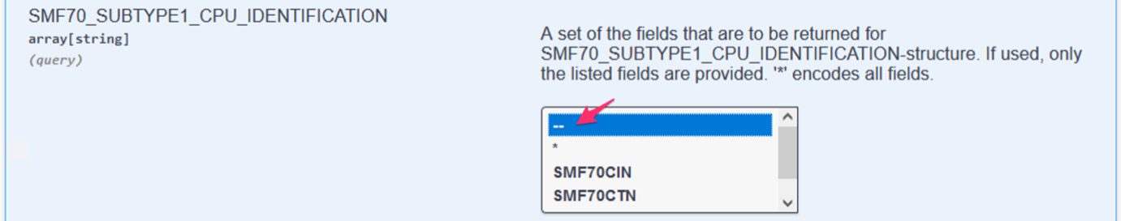

1. Select the following fields from SMF70_SUBTYPE1_LOGICAL_CORE_DATA section:

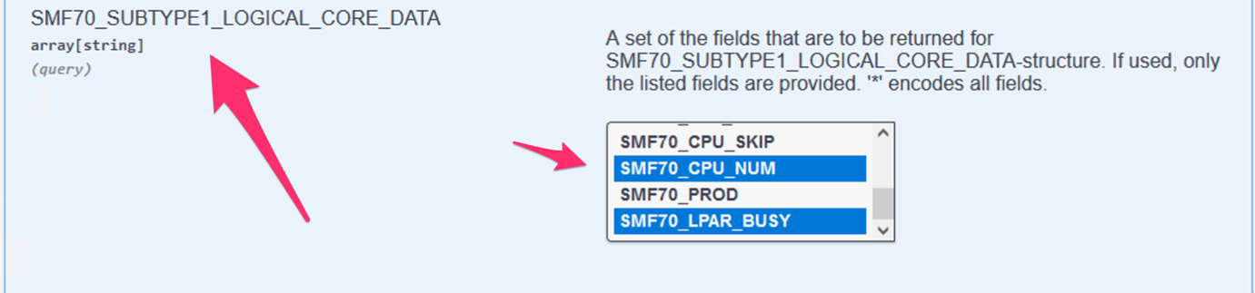

* + SMF70_CORE_ID.
  + SMF70_CPU_NUM.
  + SMF70_LPAR_BUSY.

**Note:** When selecting multiple fields, you must hold the Control key on your keyboard.

1. Click **Execute**, after the last SMF section of this endpoint.

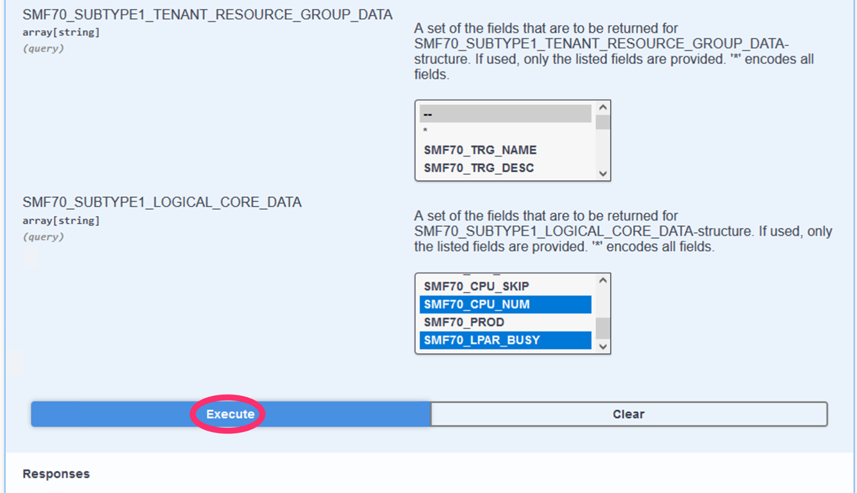

The result is the JSON document with the Return code 200.

JSON provides the array of the records that contain only the specified fields from SMF 70 subtype 1 from the provided data set. The records are filtered by systemName, startTime, and startDate.

You can use the slider to scroll up and down:

The Request URL contains the URL of the current request:

<https://share.centers.ihost.com:444/zosmf/zosdg/smf/v1/smf/type/70/subtype/1?datasetName=PMUENCH.SMFDATA.SMF7X.RECORDS&systemName=JB0&startTime=2022-05-04T11%3A00%3A00.000&endTime=2022-05-04T12%3A00%3A00.000&SMF70_SUBTYPE1_CPU_IDENTIFICATION=&SMF70_SUBTYPE1=&SMF70_SUBTYPE1_CPU_CONTROL=&SMF70_SUBTYPE1_PR_SM_PARTITION_DATA=&SMF70_SUBTYPE1_CPU_DATA=&SMF70_SUBTYPE1_ASID_AREA=&SMF70_SUBTYPE1_PR_SM_LOGICAL_PROCESSOR_DATA=&SMF70_SUBTYPE1_PRODUCT_SECTION=&SMF70_SUBTYPE1_TENANT_RESOURCE_GROUP_DATA=&SMF70_SUBTYPE1_LOGICAL_CORE_DATA=SMF70_CORE_ID&SMF70_SUBTYPE1_LOGICAL_CORE_DATA=SMF70_CPU_NUM&SMF70_SUBTYPE1_LOGICAL_CORE_DATA=SMF70_LPAR_BUSY>

1. Copy the **Request URL** content into the clipboard (right click and copy with the mouse).

Open the new tab in the browser, paste the content of the clipboard in the address bar and press **ENTER**.

You get a convenient format of the JSON document, with the possibility to expand and collapse the sections in the document.

Review the content and close the tab when done.

Now you’ve learned how to make the REST request with more extensive use of other optional parameters to filter the data.

# Next steps

Did you find the scenarios useful? Consider some next steps.

## Use IBM® z/OS® Data Gatherer SMF REST APIs

Now, you are familiar with using z/OS Data Gatherer SMF REST services to retrieve SMF data and check the status of the data set. You can use this knowledge by trying these services in your own programs.

## Learn more about z/OSMF Data Gatherer REST services

For more information about z/OS Data Gatherer REST services, see the z/OS Data Gatherer publication in the IBM Documentation: <https://www.ibm.com/docs/en/zos/3.1.0?topic=zdgpg-accessing-data-using-zos-data-gatherer-rest-services>